# **USA FIFA World Cup Tickets: USA player countdown to the World Cup, McKennie has a Juve future**

USA FIFA World Cup Tickets: The initial weeks of the World Cup season have seen some favorable starts. Norwich City's Josh Sargent continues to bang in the goals, with his count against Portsmouth previously philanthropic him three in the new season. Chris Richards and Crystal Palace tenable an inspiring road shutout at Chelsea, and Sergino Dest sustained his fine performance for PSV Eindhoven.

Football fans around the world are counting down to the FIFA World Cup. The ultimate celebration of sporting excellence and global passion. Take your experience to the next level with exclusive [**USA FIFA World Cup Tickets**](https://www.eticketing.co/sports-tickets/fifa-world-cup-tickets/usa-fifa-world-cup-tickets/), available now at eTicketing.co. Immerse yourself in the thrill, drama, and unforgettable moments as they unfold live, right at the heart of the action. Don’t miss your chance to witness football’s most iconic spectacle. Secure your FIFA 2026 Hospitality packages today!

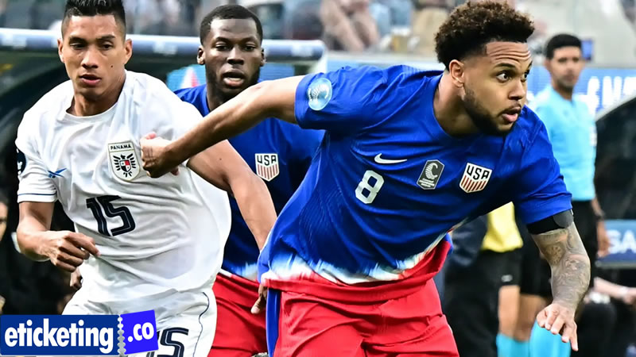

The most notable presentations of the stay came from companies in Christian Pulisic and Johnny Cardoso, who have had some concerns around them, not all of them optimistic. Throughout the period, ESPN will be tracking the progress of the U.S. men's national team player pool, bringing insights into players whose form or suitability has made them particularly fascinating.

Football World Cup 2026 followers worldwide can secure their [**FIFA World Cup Semi-Final Tickets**](https://www.eticketing.co/sports-tickets/fifa-world-cup-tickets/fifa-world-cup-semi-final-tickets/) through our online platform, eticketing.co. With a user-friendly interface and exclusive deals, fans can effortlessly book Football World Cup 2026 Tickets for thrilling FIFA 2026 matches at discounted prices. Do not miss the chance to witness the world’s greatest FIFA World Cup 2026 event live.

## World Cup Tickets: USA Players Making Their Mark Ahead of FIFA World Cup 2026

We call it the USA Player Countdown to the gentlemen's World Cup. ESPN will total down to June 11 every week, so that way, when the U.S. team is announced for this extremely expected World Cup on home soil, no names on that 26-man list will originate as a surprise. Welcome to the USA player Countdown to the World Cup. Only 295 days to go.

Experience the thrill of the FIFA World Cup with exclusive [**World Cup Tickets**](https://www.eticketing.co/sports-tickets/fifa-world-cup-tickets/) from eTicketing.co. Enjoy VIP treatment, premium seating, and unmatched comfort. Whether you’re looking for Football World Cup Hospitality, eTicketing.co offers the ultimate FIFA 2026 hospitality for an unforgettable experience. Book now and secure your World Cup tickets for the world’s biggest football event!

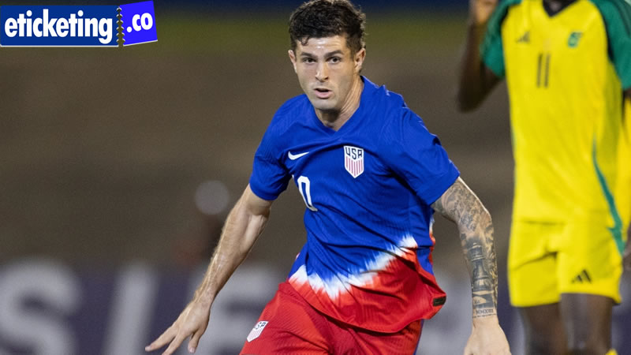

His decision finally got him back to concentrating on his real presentations. And after trembling off an ankle injury, Pulisic scored for his club, scoring Milan's second goal from a shrill greeting and surface on the try in what was a 2-0 victory over Bari in the Coppa Italia. The 66-minute presentation armor-plated a truism around Pulisic and his USA teammates. If he plays well, he'll be acclaimed. If he doesn't, he'll be disapproved. Might some of that censure be ended at the top? Possibly. Click to [**read more**](https://blog.eticketing.co/brazil-fifa-world-cup-tickets-can-brazil-end-its-painful-world-cup-title-drought/).

## FIFA 2026 Tickets: Christian Pulisic’s Form and Pressure on the International Stage

But similar to it or not, this is what he ended up with, and by means of his docuseries as a platform to protest about said censure won't modify that. With next summer's World Cup now only 10 months away, the inspection on Pulisic and his drama is only sure to increase. His twitch to the season is, however, hopeful. There has been sufficient head-scratching when it originates from Cardoso and the USA team.

At Xchangetickets, football fans can securely buy or sell [**FIFA World Cup Tickets**](https://www.xchangetickets.com/sports-tickets/football-tickets/fifa-world-cup-tickets/) with ease, whether it’s Soccer World Cup Tickets, FIFA 2026 Tickets, or the highly sought-after FIFA World Cup Final Tickets. Our platform connects you with genuine fans worldwide, offering a wide range of options, including FIFA World Cup 2026 Tickets, Football World Cup 2026 Tickets, and general Football World Cup Tickets. With our safe and reliable marketplace, you can list your tickets for sale or grab your dream seats at the click of a button, making it simple to experience the thrill of live football from the exciting group stage clashes to the grand finale.

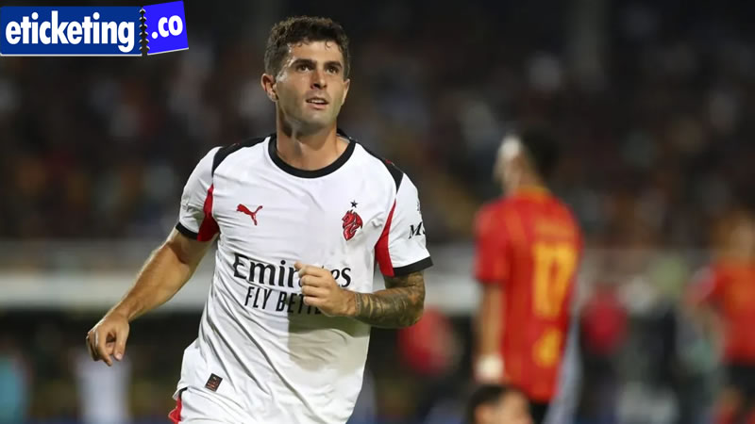

Namely, why doesn't he duplicate his FIFA 2026 form at the global level? Cardoso's entrance for Atlético on Sunday against Espanyol provoked a very different type of query. Why was he deputized out at halftime by boss Diego Simeone? It's a decision all the more bewildering given how Cardoso did. He finished 87.5% of his licenses and won 71.4% of his duels.

### **Soccer World Cup Tickets: Weston McKennie’s Uncertain Role and Future in Serie A**

Atlético remained up 1-0 when he died, only to drop the match 3-2 when Espanyol scored two goals. Simeone even acclaimed Cardoso for his play and recognized that he wanted to retrace his choices. I think I erudite a lesson he told journalists afterward. I'll take something away from that. There's an example for me. Given that Cardoso received compliments, it's a jump that bodes well for constant singing time on a very inexpensive squad.

Passionate football fans worldwide are counting down to the FIFA World Cup Final. The ultimate stage in global football. For a chance to witness the action live, grab your **[FIFA World Cup Final Tickets](https://www.eticketing.co/sports-tickets/fifa-world-cup-tickets/fifa-world-cup-final-tickets/" \t "_blank)** now at eTicketing.co. This is more than a match; it's a once-in-a-lifetime experience you won’t want to miss. Secure your place in history today! Book FIFA 2026 Hospitality Now.

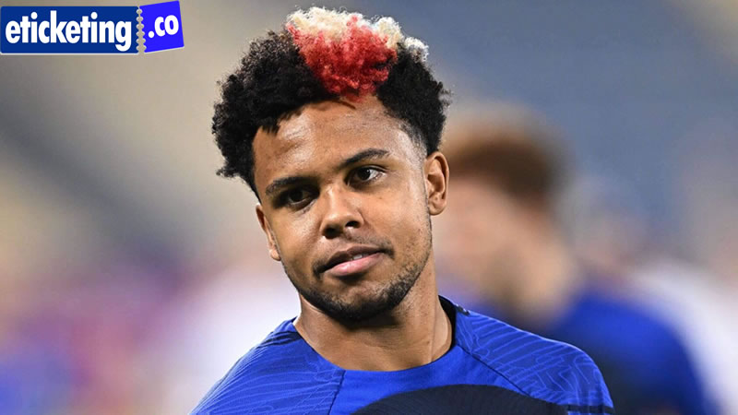

Now the task for Pochettino is to find a way to get the best out of Cardoso when he dons an unlikely red, white, and cobalt sweater. There's continuously a danger in interpreting too much into the preseason. There are youngsters to try out, fitness levels to manage, and in the case of Juventus, there's recovery from a packed summer that included the FIFA World Cup.

All of that said, when it comes to McKennie, how big a role will he end up playing for Juve this season? It seems to be an annual query. Last season, McKennie was ever-present, making a total of 48 league and cup appearances. But if the past three friendlies are anything to go by, the U.S. midfielder will be hard-pressed to repeat that level of activity.

### **FIFA World Cup 2026 Tickets: Young American Talents Gaining Momentum Before the World Cup**

As the Serie A opener against Genoa nears this weekend, and with manager Igor Tudor opting for a 3-4-3 formation, McKennie has seen his playing time steadily decrease, with him entering last weekend's friendly against Atalanta in second-half stoppage time. There have also been reports that he might be headed to AS Roma.

If McKennie remains with Juve as a squad player, the squad's presence in the UEFA Champions League figures to outcome in plenty of thespian rotation, but it's a less-than-ideal state for McKennie and the USA team. It also might open the door for an outlying thespian or two. Middlesbrough's Aidan Morris has awestruck in the inaugural weeks of the period.

Planning to attend the FIFA World Cup 2026? Find verified FIFA 2026 tickets and premium FIFA World Cup hospitality packages at [**eTicketing.co**](https://www.eticketing.co/). We bring the best deals for matches across Mexico, Canada, and the USA. Secure your spot now and join the world’s biggest football World Cup celebration in 2026!

Q1: Which teams have qualified for the FIFA World Cup 2026 so far?  
A1: As the qualification process is ongoing, several teams from different continents are securing their spots. Host nations USA, Canada, and Mexico are already guaranteed places, while the rest will be decided through regional qualifiers in Europe, South America, Africa, Asia, and Oceania.

Q2: How many teams will compete in the FIFA World Cup 2026?  
A2: The FIFA World Cup 2026 will feature 48 teams instead of the traditional 32. This expansion allows more nations to participate, giving fans around the world a chance to see new teams compete on football’s biggest stage.

Q3: Which players are expected to shine for the U.S. Men’s National Team in the Soccer World Cup?  
A3: Key names include Christian Pulisic, Weston McKennie, Gio Reyna, Tyler Adams, and Sergiño Dest. Young talents like Johnny Cardoso and Aidan Morris are also expected to play important roles as the U.S. prepares for a home World Cup.

Q4: How does team form at the club level impact Football World Cup performances?  
A4: Club form is crucial because it builds player confidence, fitness, and consistency before the World Cup. Players like Pulisic and Cardoso are closely watched since their club performances often set expectations for how they will perform at the international stage.

Q5: What challenges do national teams face ahead of the World Cup?  
A5: Teams face challenges such as injuries, tactical adjustments, player rotation, and balancing club vs. country commitments. Managers must also decide on final squad selections, ensuring the best balance between experienced players and rising stars.